# Project Design Phase-II

**Data Flow Diagram & User Stories**

|  |  |
| --- | --- |
| **Team ID** | **PNT2022TMID01003** |
| **Project Name** | **Project – Hazardous Area Monitoring for Industrial Plant powered by IoT.** |
| **Maximum Marks** | **4 Marks** |

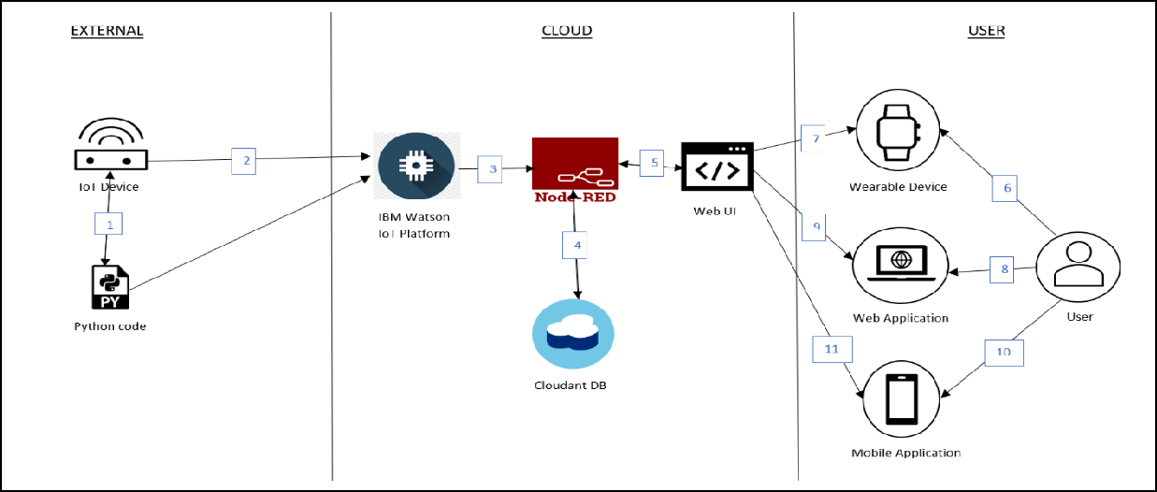

DFD Level 0 (Industry Standard)

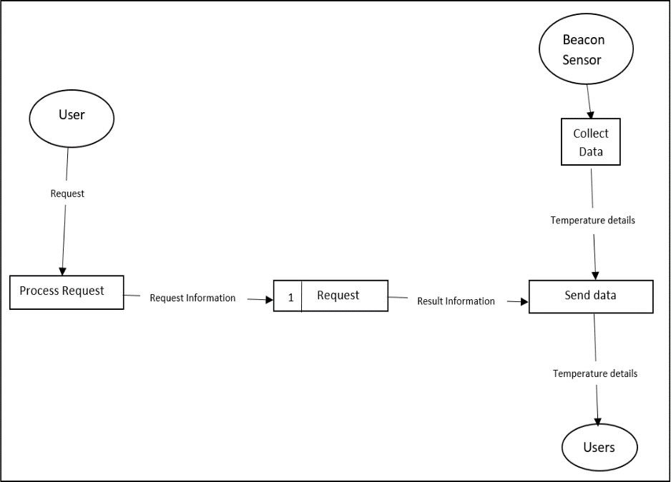

## Data Flow Diagrams:

A Data Flow Diagram (DFD) is a traditional visual representation of the information flows within a system. A neat and clear DFD can depict the right amount of the system requirement graphically. It shows how data enters and leaves the system, what changes the information, and where data is stored.

**FLOW:**

* Necessary Python code for collecting temperature details from IoT device is written.
* IoT device is connected with the IBM Watson IoT platform for gathering data.
* Next step uses Node-Red services after IoT platform is all set.
* Cloudant DB is used for storing and retrieving data.
* Node-Red services are used to create Web application and UI designs.
* (6,7,8,9,10,11) The user uses Smartwatch, Web and mobile app to receive various information and alerts.

## User Stories

### Use the below template to list all the user stories for the product.

|  |  |  |  |  |  |  |
| --- | --- | --- | --- | --- | --- | --- |
| **User Type** | **Functional Requirement (Epic)** | **User Story Number** | **User Story / Task** | **Acceptance criteria** | **Priority** | **Release** |
| Technician | Installation | USN-1 | To guarantee the plant's entire area is covered, the technician must install the smart beacons at certain locations. | Every location in the plant has a beacon. | High | Sprint-1 |
|  | Data Gathering | USN-2 | The beacons use sensors to measure the temperature in their respective areas. | One determines the temperature of various parts of the plant. | High | Sprint-1 |
|  | Data Sync | USN-3 | Real-time data transmission from the beacons to the cloud is then relayed to neighboring wearables and the administrator dashboard. | Successful data transmission to the cloud and device syncing are both achieved. | High | Sprint-1 |
| Worker | Wearable device display | USN-4 | The data transmitted by beacons nearby should be displayed by the wearable technology. | On their device, the user can view the local temperature. | High | Sprint-1 |
|  | Wearable device adjustments | USN-5 | The wearable device's size can be changed by the user to fit their needs. | The device can be modified by the user to improve comfort while using it. | Low | Sprint-2 |
|  | Wearable display customization | USN-6 | On the gadget itself, the user can customize the display to fit their needs. | To make the device's display easier to read, the user can make changes. | Medium | Sprint-2 |
|  | SMS Notifications | USN-7 | When the environment they are in reaches unsafe temperatures, the wearable gadget sends a notification to the user's phone via an API. | As soon as the beacons identify a potential threat, they send an SMS to the user to alert them to it. | High | Sprint-1 |
| Administrator | Admin Dashboard | USN-8 | The administrator's dashboard receives the data from the beacons via the cloud. | The plant administrator has access to the data from every beacon. | High | Sprint-1 |
|  | Dashboard Customization | USN-9 | The administrator can modify the dashboard to meet their unique needs and goals. | The administrator can alter the dashboard's UI. | Medium | Sprint-2 |